BLUEPRINT BUSINESS PROCESS
01.03 Master Data
Warehouse

Project Name | PT. Urecel Indonesia
Team Lead | Jennie Lou

Approved by | Name | Signature
Project Manager | Irwan Augusta
 | Iwan Budi Saputro
 | Petrus Eka Margo
Business Process Owner | Herry Setyadi
 | Bayu Pramono
 | Nor Hisyam

Table of Contents

1. Individual Process Flow 3
1.1. Warehouse Process Flow 3
1.1.1. Explanation of Warehouse Process Flow 4
1.1.2. Document Setting 6
1.1.3. Approval Rule 6
1.1.4. Alert/Notification 6
1.1.5. Journal Entry 6
1.1.6. List of Form 6
1.1.7. Remarks 6
2. Functional Gap 9
2.1. Validation 9
2.1.1. SP Transaction Notification 9
2.1.2. Addon 9
2.1.3. Formatted Search 10
2.2. User-Defined Field (UDF) 10
2.3. User Defined Object (UDO) 11
2.4. User Defined Table (UDT) 11
2.5. Other 11
2.6. Report 11
3. Integration 11
4. Comments 11
5. Version Control 12

Individual Process Flow

Warehouse Process Flow
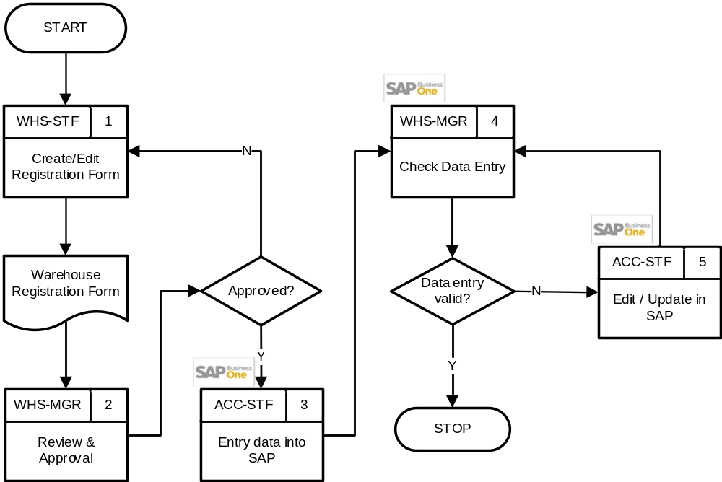

User:
- WHS-STF : Warehouse Staff
- WHS-MGR : Warehouse Manager
- ACC-STF : Accounting Staff

Explanation of Warehouse Process Flow
No | Activity | Why | Who | How | Input | Output | Interface
 | Create/Edit Registration Form | Registrasi warehouse baru | WHS-STF | Mengisi form registrasi | New Warehouse data | Warehouse Registration Form | Manual
 | Review & Approval | Mengecek kembali apakah permintaan valid dan memberikan approval. | WHS-MGR | Verifikasi form:  - Apabila data warehouse disetujui, maka lanjut ke no 3.  - Apabila data warehouse perlu dilakukan perubahan, maka kembali ke no 1. | Warehouse Registration Form | Warehouse Registration Form yang sudah di-approve | Manual
 | Entry data into SAP | Untuk memasukkan data warehouse ke sistem | ACC-STF | Input data sesuai dengan form | Warehouse Registration Form yang sudah di-approve | Data sudah masuk ke sistem | 
 | Check Data Entry | Untuk memastikan data yang diinput sudah benar | WHS-MGR | Mengecek data yang diinput  - Jika perlu dilakukan revisi data maka lanjut ke no 5.  - Jika data warehouse sudah sesuai, maka proses selesai. | Warehouse data | Valid warehouse data
 | Edit / Update in SAP | Untuk merevisi jika ada kesalahan saat menginput | ACC-STF | Edit atau update data yang salah, kemudian kembali ke no 4 agar dilakukan pemeriksaan terhadap data yang sudah di-update. | Invalid warehouse data | Valid warehouse data

Document Setting
-

Approval Rule
-

Alert/Notification
-

Journal Entry
-

List of Form
- Warehouse Registration Form (manual)

Remarks
- Warehouse Code : max 8 digits
- Warehouse Name : max 100 digits
No | Warehouse Code | Warehouse Name | Warehouse Type | Location | Enable Bin
 | TN-CN001 | TANGERANG - CONSIGNMENT | WAREHOUSE | U1 | Y
 | TN-MT001 | TANGERANG - MATERIAL CHEMICAL | WAREHOUSE | U1
 | TN-MT002 | TANGERANG - MATERIAL PAPER | WAREHOUSE | U1
 | TN-MT003 | TANGERANG - MATERIAL PLASTIC | WAREHOUSE | U1
 | TN-FG001 | TANGERANG - FINISH GOOD | WAREHOUSE | U1
 | TN-FG002 | TANGERANG - FOAMING | WAREHOUSE | U1
 | TN-FG003 | TANGERANG - RETI | WAREHOUSE | U1
 | TN-FG004 | TANGERANG - WAREHOUSE FOAM | WAREHOUSE | U1
 | TN-FG005 | TANGERANG - COMPRIBAND | WAREHOUSE | U1
 | TN-FG006 | TANGERANG - CARBON | WAREHOUSE | U1
 | TN-FG007 | TANGERANG - REBONDED | WAREHOUSE | U1
 | TN-FG008 | TANGERANG - BERIA | WAREHOUSE | U1
 | TN-FG009 | TANGERANG - DELIVERY | WAREHOUSE | U1
 | TN-UF001 | TANGERANG - UNFINISHED (UET) | WAREHOUSE | U1
 | TN-MC001 | TANGERANG - MERCHANDISE | WAREHOUSE | U1
 | TN-RJ001 | TANGERANG - REJECET/WASTE | WAREHOUSE | U1
 | TN-WP001 | TANGERANG - WIP CUTTING | WAREHOUSE | U1
 | TN-WP002 | TANGERANG - WIP FOAMING | WAREHOUSE | U1
 | TN-WP003 | TANGERANG - WIP RETI | WAREHOUSE | U1
 | TN-WP004 | TANGERANG - WIP WH | WAREHOUSE | U1
 | TN-WP005 | TANGERANG - WIP COMPRIBAND | WAREHOUSE | U1
 | TN-WP006 | TANGERANG - WIP CARBON | WAREHOUSE | U1
 | TN-WP007 | TANGERANG - WIP REBONDED | WAREHOUSE | U1
 | TN-WP008 | TANGERANG - WIP BERIA | WAREHOUSE | U1
 | TN-WP009 | TANGERANG - WIP LAB | WAREHOUSE | U1
 | TN-WP010 | TANGERANG - WIP VACUUM | WAREHOUSE | U1
 | TN-SU001 | TANGERANG - SUPPLIES | WAREHOUSE | U1
 | TN-MK001 | TANGERANG - MEKANIK | WAREHOUSE | U1
 | TN-TR001 | TANGERANG - TRANSIT | TRANSIT | U1
 | TN-SV001 | TANGERANG - SERVICE | WAREHOUSE | U1
 | JP-MT002 | JEPARA – MATERIAL (NON KABER) | WAREHOUSE | U2
 | JP-FG002 | JEPARA – FINISHED GOODS (NON KABER) | WAREHOUSE | U2
 | JP-RJ002 | JEPARA – REJECT (NON KABER) | WAREHOUSE | U2
 | JP-WS002 | JEPARA – WASTE (NON KABER) | WAREHOUSE | U2
 | JP-SF002 | JEPARA – SEMI FINISHED GOODS (NON KABER) | WAREHOUSE | U2
 | JP-WP002 | JEPARA – WIP (NON KABER) | WAREHOUSE | U2
 | JP-SU002 | JEPARA – SUPPLIES (NON KABER) | WAREHOUSE | U2
 | JP-MK002 | JEPARA - MEKANIK (NON KABER) | WAREHOUSE | U2
 | JP-TR002 | JEPARA - TRANSIT (NON KABER) | TRANSIT | U2
 | JP-SV002 | JEPARA - SERVICE (NON KABER) | WAREHOUSE | U2
 | JP-RB002 | JEPARA - REBONDED (NON KABER) | WAREHOUSE | U2
 | JP-CN002 | JEPARA - CONSIGNMENT (NON KABER) | WAREHOUSE | U2
 | JP-SM002 | JEPARA – WHS SAMPLE (NON KABER) | WAREHOUSE | U2
 | JP-MT003 | JEPARA – MATERIAL (KABER) | WAREHOUSE | U3
 | JP-FG003 | JEPARA – FINISHED GOODS (KABER) | WAREHOUSE | U3
 | JP-RJ003 | JEPARA – REJECT (KABER) | WAREHOUSE | U3
 | JP-WS003 | JEPARA – WASTE (KABER) | WAREHOUSE | U3
 | JP-SF003 | JEPARA – SEMI FINISHED GOODS (KABER) | WAREHOUSE | U3
 | JP-WP003 | JEPARA – WIP (KABER) | WAREHOUSE | U3
 | JP-SU003 | JEPARA – SUPPLIES (KABER) | WAREHOUSE | U3
 | JP-MK003 | JEPARA - MEKANIK (KABER) | WAREHOUSE | U3
 | JP-SV003 | JEPARA - SERVICE (KABER) | WAREHOUSE | U3
 | JP-CN003 | JEPARA - CONSIGNMENT (KABER) | WAREHOUSE | U3
 | JP-SM003 | JEPARA – WHS SAMPLE (KABER) | WAREHOUSE | U3
- Setiap branch hanya diperbolehkan memiliki 1 (satu) Warehouse Transit, yang digunakan khusus untuk proses Interbranch Transfer.
- Penggunaan Bin Location diaktifkan (Bin Location = Yes).
- Struktur Warehouse Sublevel terdiri dari 4 level. Namun, untuk kebutuhan operasional Urecel saat ini, hanya digunakan Warehouse Sublevel 1 untuk Warehouse Consignment Tangerang, yaitu sebagai berikut:
No | Warehouse Sublevel | Code | Description | Bin Location Code
 | 1 | C100231 | PT. MITRA LUHUR MANDIRI | TN-CN001-C100231

- Kode Bin Location yang terbentuk merupakan kombinasi kode Warehouse dan kode Warehouse Sublevel.
- Warehouse yang sudah tidak digunakan tidak dapat dihapus dari sistem, namun dapat di-Inactive-kan untuk mencegah penggunaan lebih lanjut.

Functional Gap

Validation

SP Transaction Notification
No | If | Error Message | Note
 | OWHS.U_STEM_TYPE= 'TRANSIT'  AND  OWHS.Inactive = 'N'  AND  OWHS.BPLid = :BPLid | SP Notif - 1 branch hanya boleh punya 1 transit warehouse yang active | Saat Add ataupun Update:  - Penjagaan dalam 1 Branch hanya boleh ada 1 gudang transit yang aktif.

Addon
- Menampilkan UDF ID TKU dan Warehouse Type di screen Warehouse Master Data, Tab General.
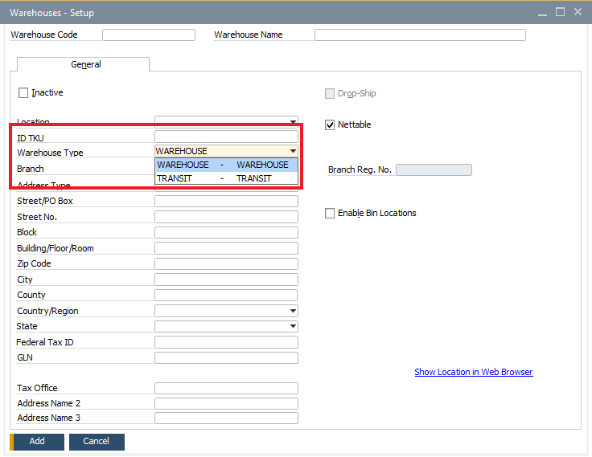

Formatted Search
-

User-Defined Field (UDF)
- Penambahan UDF ID TKU yang digunakan dalam addon CoreTax.
No | Title | Description | Type | Validation
 | STEM_IDTKU | ID TKU | Alphanumeric (30) | None

- Penambahan UDF Warehouse Type untuk membedakan gudang biasa dengan gudang transit.
No | Title | Description | Type | Validation
 | STEM_TYPE | Warehouse Type | Alphanumeric (20) | Valid Values:  - WAREHOUSE  - TRANSIT  Default: WAREHOUSE

User Defined Object (UDO)
-

User Defined Table (UDT)
-

Other
-

Report
-

Integration
-

Comments
- Mapping penamaan Warehouse
- Team klien mengisi template Warehouse di Excel
- File Excel akan diperiksa dan diupload ke SAP oleh team STEM
- Update Standard Operational Procedure to be in line with SAP B1

Version Control
Date | Author | Version | Change Reference
04-Aug-2025 | Jennie Lou | 1.00 | First Draft
18-Aug-2025 | Jennie Lou | 1.01 | Update Warehouse Data
17-Sep-2025 | Happy Niti Noor Muchsin | 1.02 | Update Business Owner
26-Sep-2025 | Happy Niti Noor Muchsin | 1.03 | Review Blueprint
13-Jan-2026 | Chatrine Sylvia | 1.04 | Update Warehouse, Bin Location, Functional Gap

